Letters for Paradise
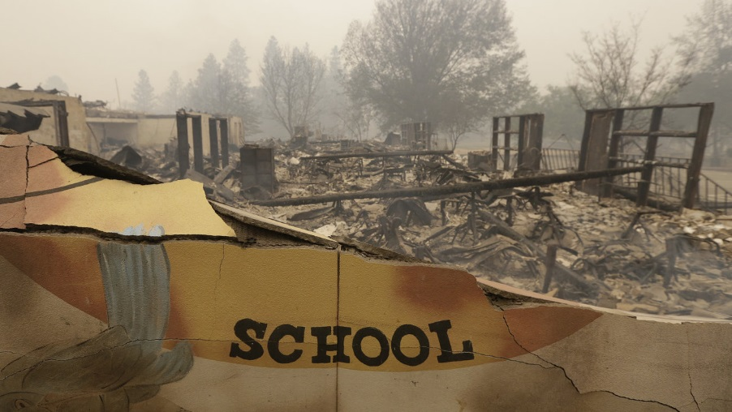
On the morning of Thursday, November 8th, a wildfire named the Camp Fire began in Northern California. About 27,000 people in Paradise and other surrounding towns had to evacuate quickly. So far, 6,700 buildings have been destroyed, most of them homes. The schools were also destroyed. Thankfully, almost everyone made it out safely. However, the town of Paradise is gone, and the fire continues for now.

Japan knows all too well what it is like for communities to be devastated by uncontrollable events, like earthquakes, tsunamis, and typhoons. In California, there are wildfires. This is the most destructive one in California history. I know people who have lost everything, including some of my extended family.

However, the people affected by the Camp Fire don’t have to lose all hope. I am reaching out to students here in Japan to take time to do one thing: write a letter to a fellow student from Paradise. There are about 3,500 students who no longer have schools, homes, or both. Your words can be powerful. They can let these students know that they are not alone, and that people, even thousands of miles away, care. Your letter would be something bright in their life that has suddenly been covered in the darkness of smoke and ash. Please include words of encouragement, hope, and good thoughts. Ask questions. Give advice. Draw pictures. Share what helps you stay positive in your life when things become difficult.

If you are interested in writing a letter, all you need to do is write the letter and give it to your respective ALT. My mother’s cousin is the superintendent of Paradise Unified School District, and I will get the letters to her personally. ALTs, if you have letters, please contact me. You can reach me at p01028@gifu-net.jp.ed, or by other means.

I thank you all from the heart for participating in this. Let’s start writing.

Sincerely,

Emily Masuda
JET Program ALT, from Durham, California
Gifu Prefectural Gifu Senior High School, Gifu City
Gifu, Japan

