Taxes in Your Home Country

- If you made money in your home country before arriving in Japan on JET, you must file a tax return in your home country.
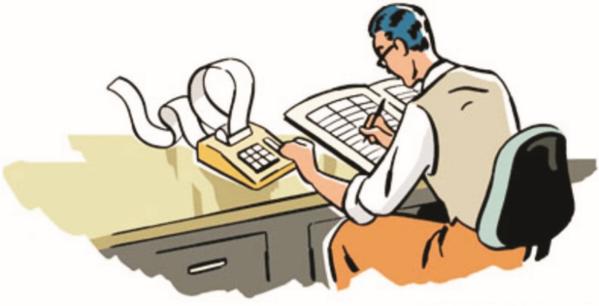
- If you are paying for any student loans, especially government disbursed ones, you should report your Japanese income to your home country. It can reduce (or even completely erase) your monthly bill, but keep in mind that interest will still accrue.

- Basic points on how to file taxes in your home country:
  - If your tax return requires an earnings statement, you need to translate it into English.
  - A pre-translated version is available on Kumamoto JET website, buried in their yearly tax guides, but I’ve lovingly ripped this page from them and put it into this packet <3
  - The earnings statement form is called 源泉徴収表 (gensen choushuu hyou) and it’s usually ready at your school/CO sometime in January.
  - You also need to convert the amount you made in Japanese yen to your home country’s currency. The US Federal Reserve publishes a list each year of the “yearly exchange rate” which you should use in your calculations (if you’re American).

Taxes in Japan

- Americans and other countries with tax treaties don’t start paying Japanese taxes until June of their 3rd year, for everyone else you start in June of your 1st year.
- Taxes are calculated based on how much money you made in Japan in the previous year.
- In your first year paying taxes, you will only have been tax eligible for part of the year, so your tax bill will be very low. After, it will rise significantly! Be aware of this!
- Some schools/COs automatically remove tax balances from your monthly salary. Others do not, meaning you have to pay your tax balance by yourself. Ask your supervisor if you are unclear on your tax situation.
- When paying your taxes, most municipalities offer two options: pay it all in June, or break it up into roughly four smaller pieces to pay off throughout the year. However, when you leave Japan, you will have to pay all of your outstanding tax balance at once. Plan ahead!

Do I have to file a Japanese tax return?

- From expatsguide.jp:
  - Company employees will have their earnings reported to the tax office by their employers. For those who have no forms of income other than salary, it is not usually necessary (with some exceptions, see below) to fill in the tax return form. Others, including freelance workers, the self-employed and those earning wages from more than one company, should complete the form and return it to the tax office. Anyone who bought a house, has a loan, or who had earnings of over ¥200,000 from a source other than salary, should also complete the form. The form refers to earnings and expenses for the previous calendar year, from January 1st to December 31st. In addition to calculating your taxable income, the form will be used to determine the rates you pay for residence tax and health insurance.
  - This means we don’t have to fill out a Japanese tax return. Yatta!
  - The only rare cases in which you need to file a Japanese tax return are: buying a house, taking out a Japanese loan, or having earnings of over \200,000 from a source other than your salary (which we JETs are not allowed to have anyway).

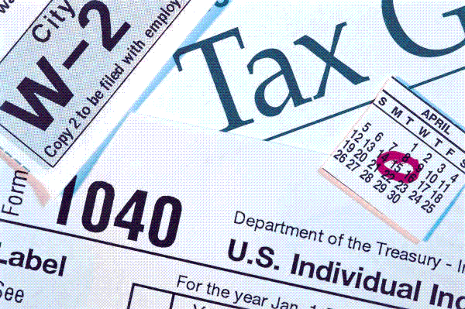

Staying in Japan for your 4th year? You need to renew your visa!

- Go to your nearest immigration office

  - Gifu City
Location | 500-8812  2-7-2, Mieji-cho, Gifu City, Gifu
Areas Served | Gifu only
Phone Number | 058-214-6168
Hours | 9:00 to 12:00, and 13:00 to 16:00  (except for Saturdays, Sundays and national holidays)

  - One in Toyama (closer for Hida folk)
Location | 939-8252  1st floor, Toyama Airport Bldg., 30 Akigashima, Toyama City, Toyama
Areas Served | Gifu, Toyama
Phone Number | 076-495-1580
Hours | 9:00 to 12:00, and 13:00 to 16:00  (except for Saturdays, Sundays and national holidays)

  - Nagoya (this one is usually EXTREMELY crowded, and I’ve heard really bad reviews about the staff working there )
Location | 455-8601  5-18, Shoho-cho, Minato-ku, Nagoya City, Aichi Pref
Areas Served | Toyama, Ishikawa, Fukui, Gifu, Shizuoka, Aichi, Mie
Phone Number | 052-559-2150
Hours | 9:00 to 16:00 (except for Saturdays, Sundays and national holidays

  - You CAN NOT go to other immigration offices (i.e. Tokyo, Osaka) while on holiday. You MUST do your paperwork at one of the centers that services the prefecture in which you live.
- Fill out the forms
  - http://www.moj.go.jp/content/001268785.pdf
  - There is a section that your school/CO needs to fill out
  - Again, this form has been lovingly ripped and added to this packet

Renewing Your Visa – Continued

- Other necessary items
  - your passport and soon-to-expire residence card.
  - a revenue stamp, 収入印紙 (shuu nyuu in shi) for \4000
    - Some convenience stores are able to sell revenue stamps, but the best place to get one is at your local Japan Post bank office/branch.
  - a new set of pictures for your new card, taken at a photo booth. Make sure they’re the correct size!

  - Photo info from http://www.immi-moj.go.jp/english/tetuduki/zairyuu/photo_info.html
    - Dimensions of photo - 4 centimeters high, 3 centimeters wide
    - Photo of only the applicant
    - Dimensions of parts excluding the edges satisfy the dimensions shown in the diagram. (Dimensions of the face are from the top of the head [including the hair] to the tip of the chin.)
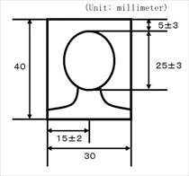
    - Subject is facing forward and not wearing a hat
    - Nothing in the background (including shadows)
    - Photo is clear
    - Photo must be one taken within three months of date of submission
    - Applicant name must be written on the back of the photo
***Photo is not to scale

Other Important Visa Info
- You can extend your visa in 1, 3, or 5 year increments. However, a 5-year visa is very difficult to obtain! You will most likely get another 3 year visa.

- The immigration office won’t put anything new in your passport—your residence card is your new “visa.” So, if you go overseas, YOU NEED YOUR PASSPORT TOGETHER WITH YOUR RESIDENCE CARD.

- The whole process takes anywhere from a couple of weeks to three months, so it’s better to start early. However, as long as you file your initial documents before your visa expires, you will be okay (I don’t recommend this, though).

