Just ask!  There are many facilities, services, and experiences available to you through your school which we are not told about outright. Take initiative and take advantage of the unique environment of your school! | Special Trash ❘粗大ごみ  These are large items which cannot be disposed of on a normal trash day (i.e. futons, chairs, cardboard, batteries, aerosol cans).  Disclaimer: Please check if your school will allow you to use this service at the school. They may only permit smaller items. Disposal rules are ESID per/city. | Special Classes  While many are related to the clubs at your school, there are occasionally travelling classes you may be allowed to attend.  Most teachers are very willing to have you join but you need to show interest. | USING SCHOOL RESOURCES  by  Emelie Vandenberg Colin Jones
 | If you ask, “How do I dispose of this item?”, the person you are speaking to might offer this as an option! | 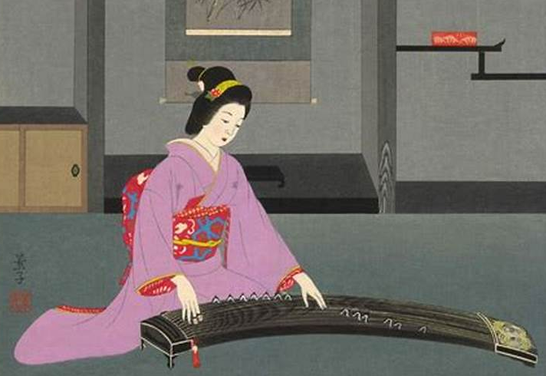 | 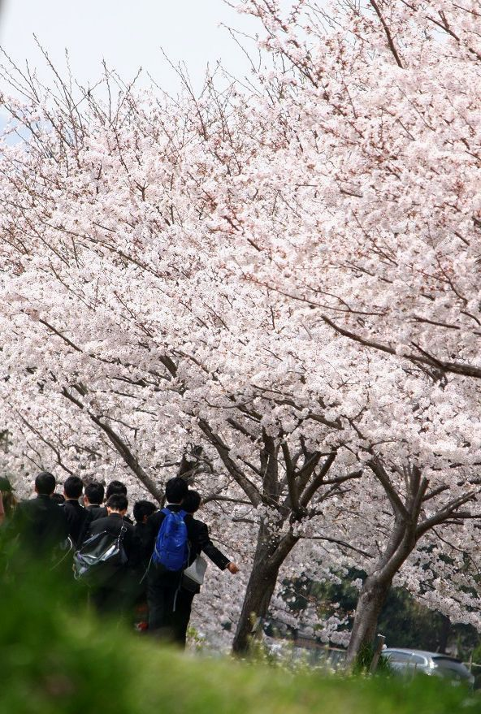
 | 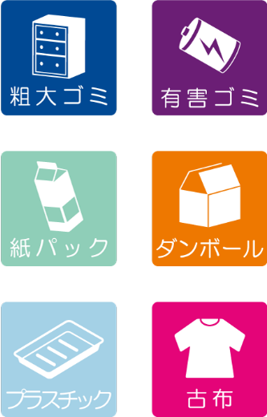 | Some Examples:  Japanese Harp  Long Bow  Tea Ceremony  Cooking  Calligraphy  Flower Arrangement  Igo  Shogi  Kendo  Sign Language

What the heck are we talking about?  There’s a lot to take advantage of on your time here at JET: cultural enrichment opportunities, sightseeing, school club activities. We are all aware of this, so we’ll skip over that.  What we really want to help with is making your day-to-day life here in Japan a little easier and more fulfilling. This is something with which your workplace and coworkers can help you. We’ll give you some ideas, as well as tips and tricks, to make your life a little easier. | Library Resources  Some ways you can utilize this resource are:  - Japanese study material  - Guides for living situations in Japan  - Class material  - Personal reading books in various languages | At your school library, you can check for and request books in a variety of languages. The options can be limited for languages other than Japanese but this is an invaluable resource nonetheless.  You also have the option of utilizing the Interlibrary Loan (ILL) System which gives you access to books from any other prefectural library in Gifu. |  | 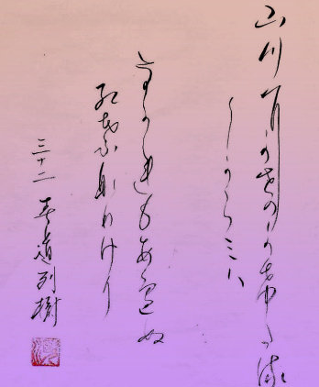
 | May I borrow a book?  本を借りてもいいですか。  hon wo karite moiidesuka?  Can you look for this book through ILL?  この本は図書館間相互貸借で見つけられますか。  kono hon wa toshokan kansougotaishaku de mitsukeraremasuka? | 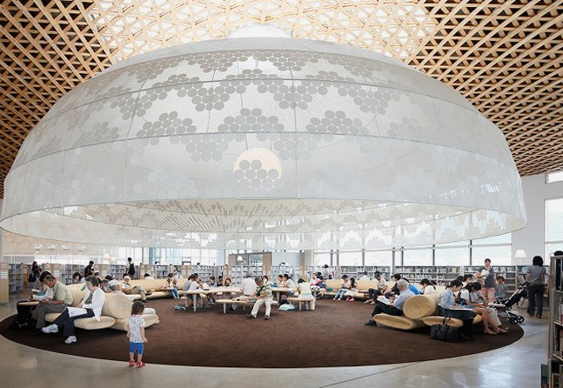 |  | You can acquire Japanese study resources!  - Study books  - Children’s lit  - Young readers  - Dual language  - eBooks  - Audiobooks
 |  |  | When is this due back?  いつ返さないといけませんか。  itsu kaesanaito ikemasenka?  What books can you get in X language?  X語でどんな本を借りることができますか。  X-go de donna hon wo karirukoto ga dekimasuka? | 