|  |
| --- |
| Gifu - Ukai 1.JPGC:\Users\p01006\Downloads\IMG-3613.JPG    **Gifu JETs**  C:\Users\p01004\AppData\Local\Microsoft\Windows\Temporary Internet Files\Content.IE5\AKZTDZCR\IMG_4154.JPGHida - Shirakawago 2.JPG  **2019 Welcome Guide**  Table of Contents  Welcome to Gifu, Japan! ………………………..…...…………...…3  Where is Gifu? ……………….……………………………………..4  Mascots………………………………………….………...…………4  Types of JET Positions in Gifu Prefecture …………...………….…5  Gifu Prefecture JET Placement Map ……………….…….………..6  JET Support System in Gifu Prefecture……………….……………7  *Your Prefectural Advisors (PAs), The Four Regions of Gifu, Your Regional Prefectural Advisors (RPAs)*  *Hida Region, Gifu Region, Tono Region, Seino Region*  Your Schedule for the First Month in Gifu………..…..………….15  *Tokyo Orientation, Gifu Life Orientation, Tips for Packing For Your First 5 Days, Gifu Work Orientation*  Packing For the JET Programme…………………………………..17  *Clothes, Shoes, Medicine, Personal Items and Toiletries, Documents, Electronics, Other Items*  Omiyage……………………………………………………..………22  Money Matters……………………………………………………....22  Weather in Gifu.…………………………………………………....23  Communication with your Predecessor…………………………...24  *Purchasing Items, Ask Your Predecessor*  Your Apartment………………………………………………….…25  *Private Apartments, Public Apartments*  Vehicles……………………………………………………….…….26  *“Bargain” Cars, Shaken, Documents Necessary to Get a Japanese Driver’s License*  Phones in Japan……………………………………………………..28  *MVNOs, Standard Cell Phone Plans, Calling Back Home*  Inkan………………………………………………………………...29  Studying Japanese……………………………………………………30  JET Resources………………………………………………………..31 |

|  |  |  |  |
| --- | --- | --- | --- |
| [Image result for ミナモ](https://www.google.com/url?sa=i&source=images&cd=&cad=rja&uact=8&ved=2ahUKEwjMpZa8vo7bAhXDoJQKHen-DEcQjRx6BAgBEAU&url=https://search.yahoo.co.jp/image/search?ei%3DUTF-8%26fr%3Dlmd_poi%26p%3D%E3%83%9F%E3%83%8A%E3%83%A2&psig=AOvVaw3uefjIC32AF-Zu37yEGrIt&ust=1526706024308422)  Welcome to Gifu, Japan!  岐阜県へようこそ! | | | |
| First time abroad? First time in Japan? 100th time in Japan?  Whichever the case, no matter what your motivation, the experiences you have in Gifu Prefecture are an important step in your personal and professional development. You have chosen to spend this chapter of your life in Gifu, assisting the local community in international relations and/or English language instruction. We are sure you will be given a lot back by the prefecture in return.  The JET Programme aims to reach the smaller communities and Gifu has its fair share. We hope you will enjoy the slow pace of life here and look forward to hearing all about your new experiences at the various conferences and social gatherings throughout the year!  Want more information about Gifu? Check out our website (often referenced in this packet)  [gifujets.weebly.com](file:///C:\Users\p01012\Downloads\gifujets.weebly.com) | | | |
| General Information Handbook  Throughout this guide, you will find references to the JET Programme General Information Handbook (GIH). The GIH is your go-to when you have questions whilst on the programme, please ensure it comes with you to Japan. If you’d prefer to save packing space, you can download the PDF version of it from CLAIRs website here: <http://jetprogramme.org/en/gih/> | | | |
| This packet was created to help you move to Gifu. More information will be given to you upon your arrival about things you need to know once you are here (i.e. health insurance, region guides, etc). This packet only focuses on what you should be doing to prepare to move to Japan.  If you have any questions, feel free to e-mail [gifupas@gmail.com](mailto:gifupas@gmail.com) | | | |
| Where is Gifu? | | | |
| C:\Users\p01006\AppData\Local\Microsoft\Windows\Temporary Internet Files\Content.IE5\62UG0S13\gifu map (train times).pngIf Honshu (the main Island in Japan) was to be completely balanced on a pin, that pin would be under Gifu Prefecture!  Gifu is in the region of Japan referred to as Tokai or Chubu. The capital city is Gifu City, towards the south of the prefecture.  Due to its central location, Gifu is an ideal prefecture for those who like to travel. | | | |
| Gifu Prefecture has all the beauty and culture of the traditional countryside, combined with easy access to Nagoya City, Japan’s fourth most populated city, in Aichi Prefecture, to the south. | |  | |
|  | | | |
| Mascots | | | |
| Minamo is the official mascot of Towns each have their own mascots as well. The  [Image result for ミナモ](https://www.google.com/url?sa=i&source=images&cd=&cad=rja&uact=8&ved=2ahUKEwjl-uamvY7bAhXRNpQKHaygDTEQjRx6BAgBEAU&url=http://www.pref.gifu.lg.jp/kensei/ken-gaiyo/seiryunokuni-zukuri/c11143/seiryuminamosyou.html&psig=AOvVaw3uefjIC32AF-Zu37yEGrIt&ust=1526706024308422)Gifu Prefecture. most popular mascot in the prefecture is  the Hida mascot, Sarubobo.  [Image result for サルボボ](http://www.google.co.jp/url?sa=i&rct=j&q=&esrc=s&source=images&cd=&cad=rja&uact=8&ved=0ahUKEwjevvnxr8bTAhXEmZQKHfgLASAQjRwIBw&url=http://www.tigdress.com/blog/11249/&psig=AFQjCNH4O1nZauWLrwneZrZu9FkelOk6rA&ust=1493442184802838)  Minamo Sarubobo | | | |
| Types of JET Positions in Gifu Prefecture | | | |
| Welcome to JET in Gifu! There are currently 66 JETs in Gifu (although there are many more non-JET ALTs running around). Here are the types of JETs in our prefecture. | | | |
| Coordinator of International Relations (CIRs) | | | |
|  | You will be placed in the Gifu Prefectural Office, at the International Exchange or Tourism Division, the Gifu International Centre, Gifu Media Cosmos Library, Minokamo City, or IAMAS. Your duties will differ according to your position.  There are 12 CIRs in Gifu Prefecture:   * 2 Chinese CIRs * 1 French CIR * 1 Brazilian CIR * 1 Filipino CIR * 6 English-speaking CIRs (Currently from Australia, the UK and USA) * 1 Lithuanian CIR | |  |
| Municipal Board of Education Assistant Language Teacher | | | |
|  | If your JET Placement was a city, town, or village, you are a Municipal Board of Education Assistant Language Teacher. You are employed by the Board of Education (BoE) in your city, town, or village, and your paycheck will come directly from that entity. It is likely that you will spend most of your time based in a junior high school and make visits to other schools in the area, most commonly, elementary schools. You may also teach adult night classes or adorable kindergarteners. Your supervisor will likely be a local BOE employee, overseeing all ALTs hired by your BoE.  There are 37 Municipal ALTs from 13 different BoEs in Gifu Prefecture. | |  |
| Public Senior High School Assistant Language Teacher | | | |
|  | If your JET Placement was Gifu Prefecture and you later received a high school and city placement, you are a Public Senior High School Assistant Language Teacher. You are placed at one high school, and teach there five days a week. Infrequently, you will be requested to make visits to other schools in your area. You are employed by Gifu Prefecture Board of Education, which is your Contracting Organization (CO). Your base school is your Host Institution. Your supervisor will be a Japanese Teacher of English (JTE) who works at your school and with whom you will have a lot of direct contact.  There are 16 Public SHS ALTs in Gifu Prefecture. | |  |
| Private Senior High School Assistant Language Teacher | | | |
|  | You are placed at one school. Your Contracting Organization (CO) and base school are the same. You will work at this high school but may sometimes be asked to participate in events at an affiliated elementary or junior high schools. Your supervisor will be a Japanese Teacher of English (JTE) who works at your school and with whom you will have a lot of direct contact.  There is 1 Private SHS ALT in Gifu Prefecture. | |  |
| Gifu Prefecture JET Placement Map  The numbers of JETs in each city, town or village…    **2**  **1**  **1**  **15**  **1**  **15**  **1**  **7**  **1**  **1**  **3**  **1**  **1**  **3**  **3**  **1**  **1**  **4**  **1**  **3**  **1**  -Seino Region -Gifu Region -Tono Region -Hida Region | | | |

|  |
| --- |
| JET Support System in Gifu Prefecture |
| There is no doubt: living in a foreign country is a rewarding experience. However, like most undertakings of worth, it is likely to sometimes be tough and challenging. Due to this, the JET Programme in Gifu has an extensive support network to help you whenever needed.  Picture |
| Your Prefectural Advisors (PAs) |
| For the JET Programme, there are Prefectural Advisors in every prefecture and designated city in Japan. Their job is to be at the center of the support network that has been created to help JETs settle into their new lifestyles and also to help them with any problems that arise during their time on the JET Programme.  In Gifu Prefecture there are four PAs: one CIR PA and one Japanese PA (JPA) who work at the International Exchange Division of the Gifu Prefectural Government and one ALT PA and one JPA who work at the Education Training Division of the Gifu Prefecture Board of Education. They are all located in Gifu City. If you have any difficulties either prior to your move to Japan or during your time here, please don’t hesitate to contact the PAs for assistance.  **You can reach the Gifu PAs with any questions at:** [gifupas@gmail.com](mailto:gifupas@gmail.com) |

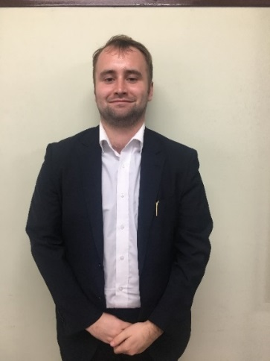Peter Collins- CIR PA, International Exchange Division

Peter is from England and will be entering into his 4th year on the JET Programme. He studied physics in the United Kingdom and Germany before coming to Gifu to work as a CIR. In between eating far more tonkatsu than is healthy and wasting huge amounts of money on gentei (limited edition) snacks, he works as the CIR PA. He is very much looking forward to seeing you all in Gifu!

Mizuki Kunieda – JPA, International Exchange Division

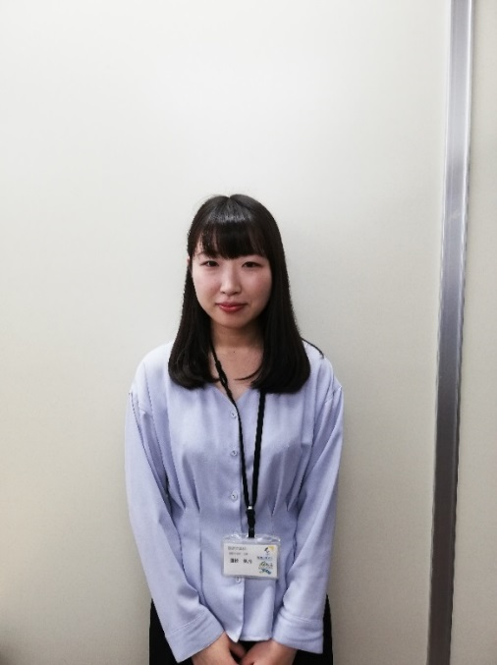Kunieda-san is the Japanese Prefectural Advisor (JPA) in the International Exchange Division of the Gifu Prefectural Government. She is from Ono Town, in the western Seino region of Gifu Prefecture. In her university days she lived in Nagoya. She was bad at exercise but enjoyed moving her body, so she joined the five-a-side football club at her university. Nowadays, her hobby is to travel and sample the delicious foods of different places. She’s also a great lover of ramen, and is always looking for delicious ramen shops. You might be a little nervous, but she sincerely hopes that you will enjoy your life in Gifu. Please feel free to contact her if you have any problems! She’s looking forward to meeting all of you in Japan!

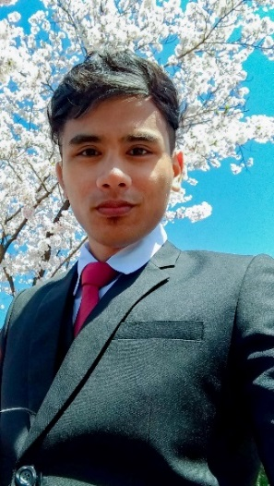Angelo Pascual - ALT PA, Gifu Prefectural BoE

Angelo joined the JET Programme in August 2018, thus realizing his dream of living in Japan. Aside from being the new ALT PA, he also teaches at Gifu Nōrin Senior High School where he can buy the freshest produce and play with farm animals. Angelo’s profile is as diverse as his home country, the Philippines. A globetrotting registered nurse who has a strong penchant for sweets, anime, history and current events, his past adventures include living in Saudi Arabia for a number of years; volunteering as an English teacher in Chile and traveling to more than 30 countries, among others. He is excited to meet the incoming Gifu JETs and be a supportive “senpai” for everyone.

Yumiko Ogura – JPA, Gifu Prefectural BoE

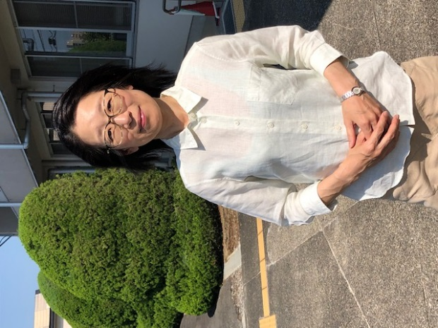Yumiko Ogura is a Teachers’ Consultant for Japanese Teachers of English. She works for the Educational Training Division of the Gifu Prefectural Board of Education. She is also a Prefectural Adviser for the JET Programme in Gifu, working with the other three PAs and both ALT and CIR members of JET. Her family name, Ogura (小倉) means “a small storehouse.” A city in the Kyushu area has the same kanji but is pronounced “Kokura.” Ogura also is part of the name of a Japanese sweet “ogura-an” which is made of sweet beans. If some of you are interested in old Japanese literature, you may find the name Ogura in a traditional card game using “waka,” which is an old style of Japanese short poems.



Laura Duvall is the current ALT PA working at the Prefectural Board of Education. However, she will be finishing her contract in August when Angelo Pascual will take over the position. Until then, she is here to answer any questions you might have about JET prior to your move to Gifu Prefecture.

|  |  |
| --- | --- |
| The Four Regions of Gifu | |
| Hida  Tono  Gifu  Seino | For the purposes of the JET Programme, Gifu Prefecture is divided into four different regions: Hida, Tono, Gifu and Seino. These four regions roughly correspond to how Gifu Prefecture administrates the different Boards of Education. The regions are purely for managerial purposes, so you’ll definitely be seeing people and places in all of them. Traveling between the regions is fast and easy. |
|  | |
| Your Regional Prefectural Advisors (RPAs) | |
| It is difficult for the PAs to maintain close contact with all 66 JETs directly due to the number and the size of the prefecture. For this reason, the Regional Prefectural Advisor (RPA) system was created to make sure that there is someone to turn to in each of the four geographical regions.  The RPAs are experienced 2nd-5th Year JETs. They live close by if you have any problems throughout the year. With their time spent in the prefecture, they have detailed knowledge of the region and are happy to do anything they can to help. C:\Users\p01006\Desktop\IMG_1887.jpg   |  |  |  |  | | --- | --- | --- | --- | | **Seino**  Daniel  Cedric | **Hida**  Colby Kamala  Chevaughn | **Tono**  Logan (not pictured)  Clint | **Gifu**  Gaelle Julia Hannah | | |
| **Tono**  **Hida**  **Gifu**  **Seino** | |

Hida 飛騨

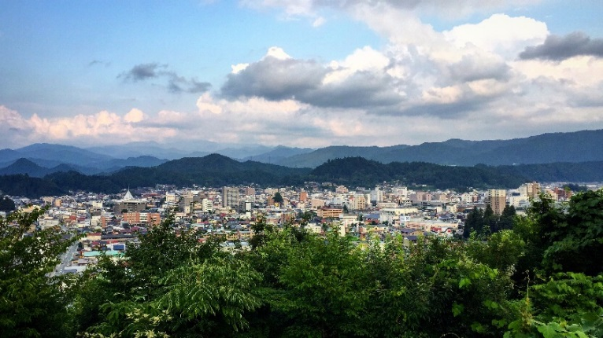In the northern most region of Gifu Prefecture is the Hida Region. Hida is divided into Gero City, Takayama City, Hida City and Shirakawa Village.

Takayama is the largest of the cities, boasting Takayama Matsuri, which is known to be one of Japan's three most beautiful festivals. Takayama has an array of cultural and natural delights with a thriving central hub of refined dining, dingy Izakayas and everything in between.

North of Takayama is Hida City, a picturesque town which has grown immensely in popularity for international and domestic tourists since the release of the famous Japanese movie, *Kimi No Na Wa (Your Name*).

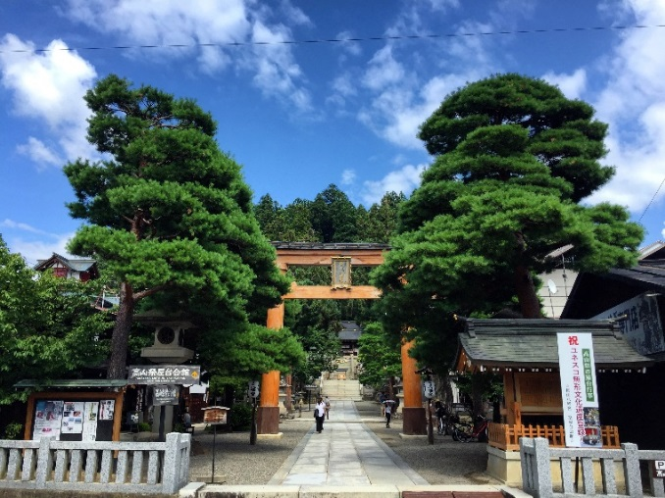Gero City is the southern-most part of the region, known for its hot springs that make up one of the top three onsen areas in Japan according to Hayashi Ranza (a Confucian scholar from the Edo Period).

Shirakawa-go is a village located in the north of the region. It's famous for its gassho-style houses, a style of thatched-roof housing, built from as early as the 1800s that people still live in today.

**About the Hida RPAs**

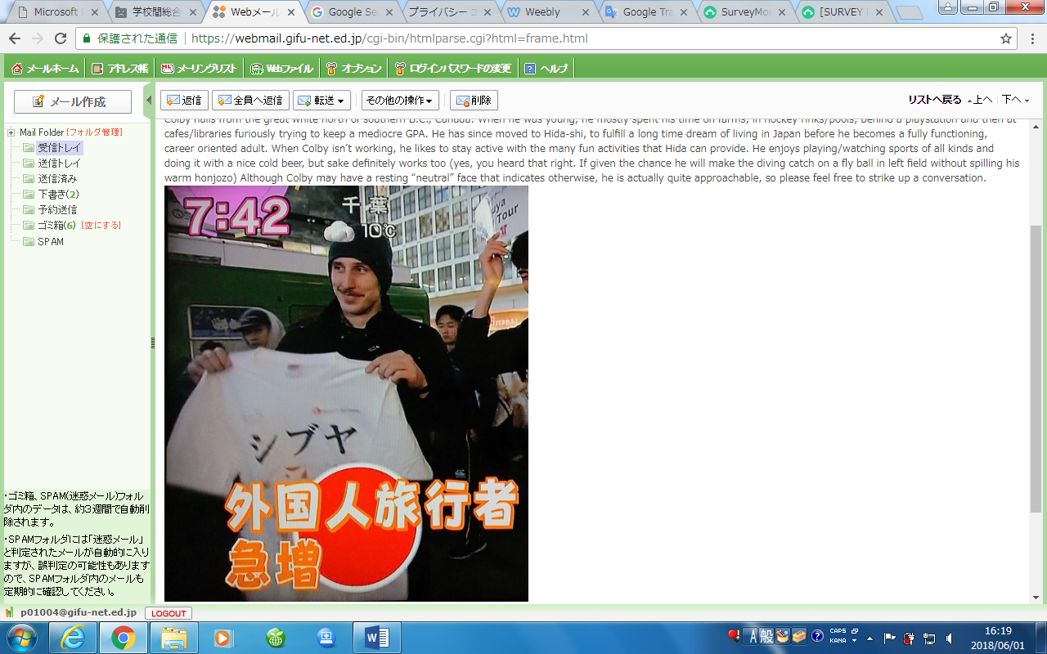Colby Draney – 4th Year ALT, Hida BoE

Colby hails from the great white north of southern B.C., Canada. When he was young, he mostly spent his time on farms, in hockey rinks/pools, behind a playstation and then at cafes/libraries furiously trying to keep a mediocre GPA. He has since moved to Hida City, to fulfill a long time dream of living in Japan before he becomes a fully functioning, career oriented adult. When Colby isn’t working, he likes to stay active with the many fun activities that Hida can provide. He enjoys playing/watching sports of all kinds and doing it with a nice cold beer, but sake definitely works too (yes, you heard that right. If given the chance he will make the diving catch on a fly ball in left field without spilling his warm *honjozo*) Although Colby may have a resting “neutral” face that indicates otherwise, he is actually quite approachable, so please feel free to strike up a conversation.

*(About the Hida RPAs continued on the next page…)*

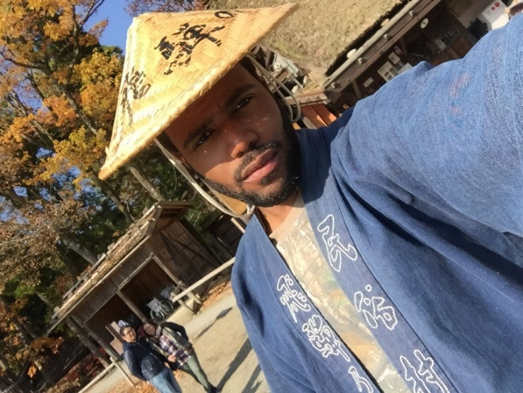Chevaughn Whyte – 3rd Year ALT, Takayama BoE

Chevaughn Whyte is a 3rd year JET from Kingston, Jamaica, living in the High Mountains (Takayama) of Hida and yes, he likes reggae music. He is a geologist by his course of study, and held the capacity of a GIS Engineer back in Jamaica before coming to Japan. Other than his dedication towards his *genki* students, he also plans to obtain a mastery level in *Aikido* within the next 2 years. He enjoys anything that has to do with being outdoors, which includes: hiking, chasing waterfalls and swimming in random rivers. So, if you’re interested in going on epic adventures through the *inaka* (countryside) he is definitely your guy to chat with.

Kamala Copeland – 2nd Year ALT, Gujo HS

Kamala hails from sweet sweet Jamaica. This tropical gem is becoming a citizen of the world through travel. A graduate of the University of the West Indies in Journalism, Spanish and French; A Polyglot & Itinerant, she hopes to travel the world helping and motivating people to chase their dreams! She’s a little introverted but just mention Star Trek (NOT Star Wars) or ice cream and she will come to life, tread carefully though, she can go on for hours about it… she has after all watched all 6 series … and the movies! She also loves introducing people to Jamaican cuisine. Hungry? Stop by!

Gifu 岐阜

[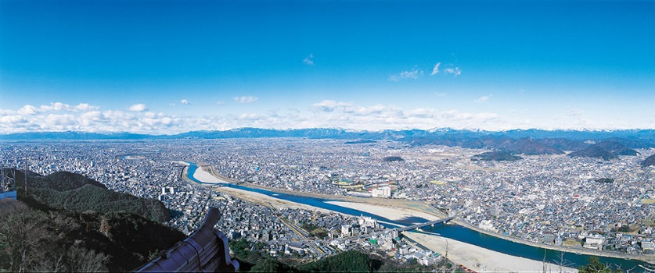](https://www.google.com/url?sa=i&source=images&cd=&cad=rja&uact=8&ved=2ahUKEwjd_o_2rLHbAhUMVrwKHZ-dDfIQjRx6BAgBEAU&url=https://www.gifucvb.or.jp/en/01_sightseeing/01_02.html&psig=AOvVaw3cJgJr5K115Ywzy9zg-S1s&ust=1527904213300777)Welcome to Gifu!

Whether you are looking for a hipster place to chill like Media Cosmos or want to experience something more traditional - like the third biggest Buddha statue in the whole of Japan- you can do it all in Gifu city! You can even get cultured in Tamami street which is full of restaurants, bars and drunk salarymen at night.

Outside the made city there is even more: Kakamigahara is home to one of the best cherry blossom viewing spots in Japan. The Usuzumi Zakura tree of Neo Valley in Motosu is over 1500 years old but if nature isn’t your style Motosu city is also home to one of the biggest shopping malls in Japan. Just minutes from Motosu is Kitagata where you can find many small, traditional Japanese temples and also some very industrial-looking architecture! Gujo City aka “water city” is famous for the food replicas that are sold and used all over Japan. Seki City is not only known for its knives and cutlery but also for its pond that looks like one of Monet's paintings; it has attracted many people – and gained lots of Insta likes - recently.

Can't wait to see you guys! ^o^

*(About the Gifu RPA’s on the next page…)*

**About the Gifu RPAs**

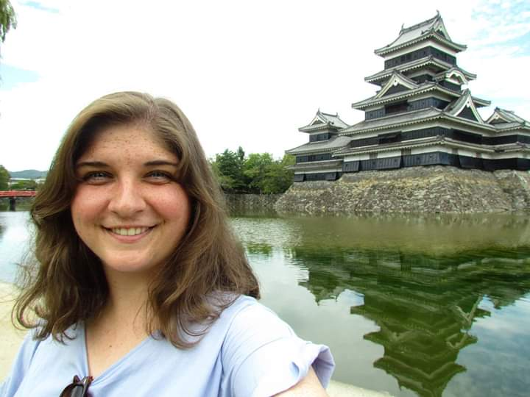Julia Taylor – 2nd Year ALT, Gizan HS

Julia is a special education teacher from Toronto, Canada. When she is not writing, cooking or napping, Julia loves to travel throughout and beyond Gifu Prefecture. She is looking forward to meeting all the new JETs! ☺

Gaëlle Lagrouas – 4th Year CIR, Gifu International Exchange Division

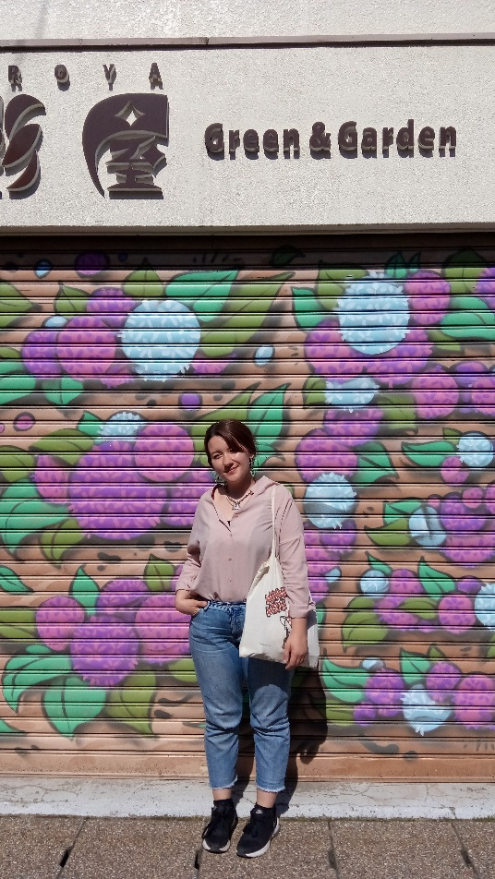Gaëlle comes from the marvelous country of delicious baguettes, incredible cheese and good wine named France. As a typical Parisienne, Gaëlle enjoys good food and good drinks in Gifu’s night district and Nagoya during the weekend. She is also the wikipedia of going-out and spreading the word about good dancing, eating and drinking spots. Her undergraduate study in English and Japanese Applied Language with an International Exchange specialization allowed her to study in Fukuoka for one year where she had so/too much fun. Back to France and reality, she started a Japanology master's degree and a Cultural Management and Trilingual Communication master's. She lived the Tokyoite life for one year as a French Teaching Assistant at a women's university before arriving to Gifu in summer 2016. For those who don't know her yet, you will have to learn to excuse her French...accent!

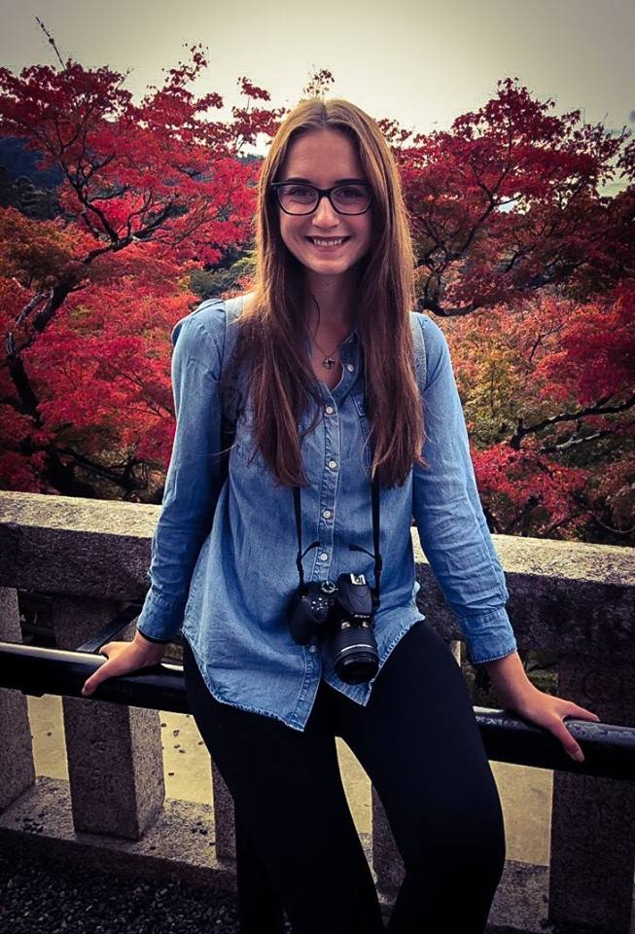Hannah Wehrer – 2nd Year ALT, Gifu Shotoku Gakuen HS

Hannah and is from the state of Washington in the USA. She graduated from Western Washington University with a degree in East Asian Studies and a TESOL certificate. As someone who comes from a valley surrounded by mountains and rivers, she was thrilled to find out how similar Gifu was. She enjoys some outdoor sports like hiking and kayaking or even just walking around parks on days off. If you don't find her outside, she’s probably inside playing video games or hanging out with friends. She is looking forward to meeting you all and if you ever want to hike up Mt. Kinka or try out some new restaurant never hesitate to hit her up!

Tono 東濃

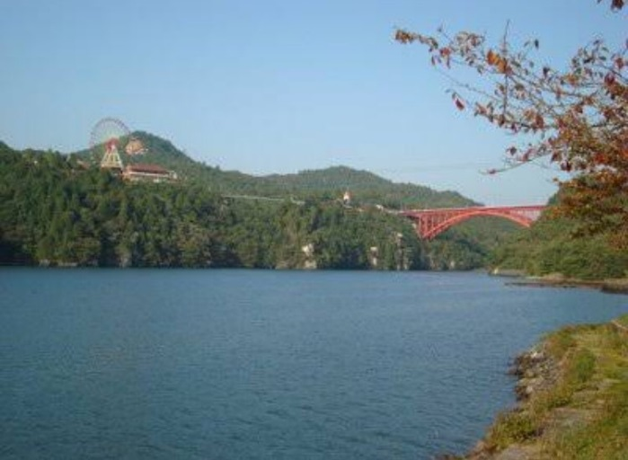Welcome to Tono!

Tono region is nestled in the southeastern mountains of Gifu Prefecture. The main cities in Tono are Nakatsugawa, Ena, Mizunami, Toki, and Tajimi, all of which are connected by the JR Chuo train line. Tono has all of the charm of the Japanese countryside, with the convenience of the Chuo Line, which typically comes every 15-20 minutes, and will take you right into Nagoya (Japan's 4th largest city). Known for its ceramics, dance festivals, kyudo, hiking trails, and all kinds of interesting activities, Tono can best be described as the place you never realized you wanted to live until you've lived there.

**About the Tono RPAs**

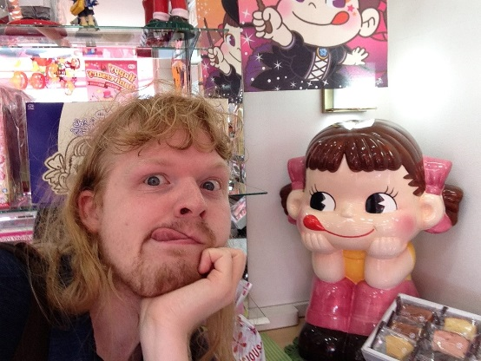Logan McCarthy – 2nd year ALT, Toki BoE

Logan McCarthy is an Irish-American second year prefectural ALT from Wrentham, Massachusetts (just off Boston’s front yard). Backed with a Bachelor’s in Graphic Design and two-year’s experience pointing out turtles and swans for grade schoolers at a wildlife sanctuary, he made the courageous leap to teaching English in Japan. He lives on the homey, northernmost tip of Toki, where he likes to play Pokemon Go when the weather is nice. With the hub of the city being a thirty-minute walk away, he often hits the town for beef bowls at Sukiya or hundred-yen goods at Mikiya. In any given week, you can find him chilling with Clint (see other Tono RPA), making music and videos, or conquering claw machines in Nagoya.

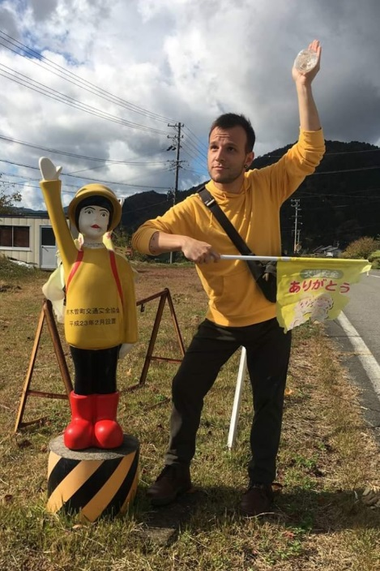Clinton Bragger – 2nd Year ALT, Tajimi Kita HS

Clinton Bragger is a Swiss-American, second year prefectural ALT from Los Angeles, California. With a passion for filmmaking, and having been born and raised in the film capital of the world, Clint thought it'd be wise to get away for a while before he inevitably finds work the same city he's lived in his entire life. Though he currently lives in Mizunami City, he teaches at Tajimi North High School. Upon moving to Japan, he found a love for Kyudo (traditional Japanese long bow archery), which he practices sometimes up to six days out of the week. When he's not honing his Kyudo skills, you can usually find him hanging out with Logan (see other Tono RPA), working on short films and videos, or drinking a cold one at Mizunami's local watering hole, Tonmaru.

Seino 西濃

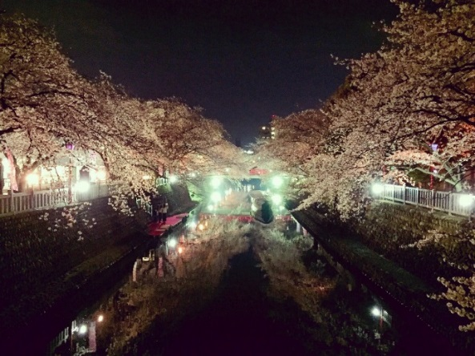Seino is the westernmost part of the prefecture, providing a buffer between Shiga and Fukui prefectures and the Gifu region. It is made up of four districts and two cities. The name is a long established amalgamation of the kanji for “west” (西) and Mino (美濃, the ancient name for southern Gifu).

Gifu is known as the land of clear waters, and this is nowhere more obvious than in Seino. It lays claim to all of the Ibi River, one of the three major rivers in the prefecture, and the other two, the Kiso and Nagara rivers, both gather in Seino before they flow out to sea.

Ogaki, the main city of the region, is also known as the “water capital(水京)” of Japan for its clean and ever flowing springs that liter the city. It’s other major claim to fame dates all the way back to 1690, when the famous Japanese poet, Matsuo Basho, actually walked from Edo (modern-day Tokyo) to Ogaki.

Seino is also the site of arguably Japan’s most famous battle in Sekigahara. Fortunately very few battles take place in Seino nowadays, though Fukui could decide to invade at any time (not really, this is Japan after all.) Luckily, Ogaki is on the Tokaido JR line, the main train line through the prefecture so you can easily evacuate to other parts of Japan quickly.

**About the Seino RPAs**

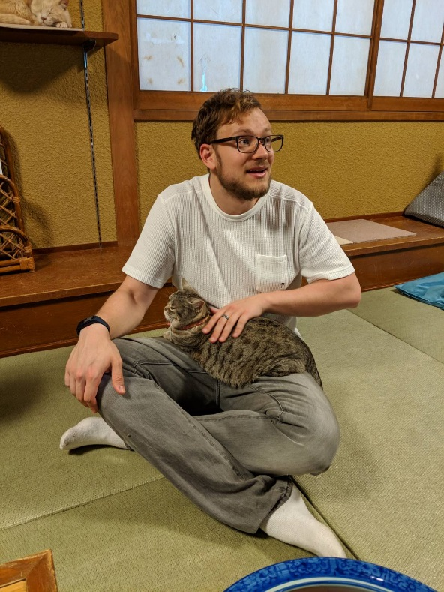Cedric Osborn-Brown - 5th Year ALT, Ibigawa BoE

Cedric is the municipal ALT working deep in the mountains of Ibigawa Town. He claims to be from Southern Utah, but has lived so many places that the question ‘Where are you from?’ always poses a big problem. Despite years in a desert, Cedric still loathes the heat of summer and often turns into a puddle of sweat as the thermometer ticks higher. When not trying to stay solid in the teacher’s office or the classroom (or enjoying the chill of winter), he enjoys visiting new places, relaxing with his cat (not the one pictured), giving people rides and has recently started hitting the gym regularly. If you ever need a battle-hardened opinion on life as an ALT, a ride someplace, or just need a cat on your lap for an hour, he’d be glad to provide!

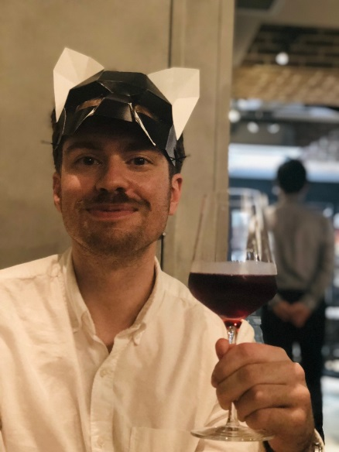Daniel Burt - 3rd Year CIR, Seino RPA

Daniel **C**oordinates **I**nternational **R**elations at the Institute of Advanced Media Arts and Sciences, a graduate school of new media art in lovely Ogaki. His mind is a television-detective-style pin-up board of interconnect nodes and nodules; but, instead of crime-scenes and suspects, the proverbial polaroids that his intellect links with psychic yarn correspond to our planet’s nations - nations whose relations, he knows, rest in his solemn hands. Mostly, the school has him translate things.

  Born in Ashland, Oregon, USA - a one-horse town locally famous for its “Shakespeare festival.” How did a podunk American town gain recognition for producing play written by a renaissance-era British playwright? International relations at work. When not coordinating, Daniel practices the martial arts of *Kenjutsu* (Japanese swordsmanship) and *Kali* (Filipino sticksmanship). He loves ramen and other noodle-based foods.

|  |  |
| --- | --- |
| Your Schedule for the First Month in Gifu | |
| Tokyo Orientation | |
| Group A  Monday, July 29th –  Wednesday, July 31st | **Sunday-** Arrive in Tokyo! Depending on when your plane arrives you might have some time to explore.  Dress code: N/A (comfortable clothes for the plane)  **Monday –** Day one of Tokyo Orientation and your first day of work as a JET Programme participant. This conference is organized by CLAIR and will go over basics to prepare you for JET. That night there will be a welcome reception where you will get to meet the other JETs heading to Gifu.  Dress code: Business formal (change of casual clothes for after work)  **Tuesday –** Day two of Tokyo Ori. During the afternoon you will meet two of your Gifu PAs who will give you detailed information about how they will take you to Gifu the next day.  Dress code: Business formal (change of casual clothes to go explore Tokyo at night, or smart casual clothes if your country’s embassy is holding a welcome party [most non-American JETs]). |
| Group B  Monday, August 5th –  Wednesday, August 7th |
| Gifu Life Orientation | |
| Group A  Wednesday, July 31st –  Thursday, August 1st | **Wednesday –** In the morning your PAs will meet you at the hotel and will bring you to Gifu by train (transport arranged by the PAs). Expect approximately 4 hours of travel time.  Upon arrival in Gifu you will meet your other two PAs and begin day one of Life Ori, your prefecture specific orientation. You will spend the night in a hotel in Gifu City (arrangements made by the PAs).  Dress code: Smart casual, suitable for travel and to attend Life Ori upon arrival (a change of casual clothes for after work)  **Thursday –** Day two of Life Ori. At midday you will be picked up by your supervisor and they will take you to your new home.  Dress code: Business formal to meet your supervisor. You will receive any luggage you sent ahead upon arrival at your school. |
| Group B  Wednesday, August 7th – Thursday, August 8th |
| **Accommodation Costs and Transportation Arrangements:**  **There is no need to worry this**, it will all be arranged for you. Just show up and we will take you!  Tokyo Ori Accommodation and Transportation: Paid for by your CO. However, at a later date, some COs may ask their JETs to pay the bill from CLAIR, and then will reimburse the money afterwards.  Life Ori Accommodation: You will need to pay for your room (about 7000\) upon arrival at the hotel. Your CO will reimburse the cost in a later paycheck. Take this into account when budgeting startup costs. | |
| Tips for Packing for your first 5 Days | |
| * We recommend packing everything you need for your first 5 days in **one carry-on sized luggage**. You will travel from Tokyo to Gifu by train, then *shinkansen* (bullet train) and then finally in a private mini-bus. This trip can be difficult if you have large or heavy luggage. * You can send your large suitcase(s) from Narita Airport (Tokyo) upon arrival. Freight cost is to be borne by the JET. Anything sent from Narita, you will not see again until the following Thursday at your new workplace. This is arranged by CLAIR and easy to do upon arrival at the airport- no prior research necessary. * Once you arrive at the Keio Plaza Hotel in Tokyo for Orientation, you may elect to send further luggage to your destination in Japan at your own cost. This again, is arranged by CLAIR and easy to do if you so wish. * Given the heat in summer, you are unlikely to be able to wear the same shirt two days in a row and get away with it, nor will you be able to do laundry easily. * Along with work clothes and after-work casual clothes for each day(see dress codes), we recommend that you pack:   + Plug adaptors for electronics   + Appropriate pajamas (you will have roommates in Tokyo)   + Toiletries   + Formal shoes (you will not need your indoor shoes until later)   + Comfortable shoes for exploring Tokyo/traveling to Gifu. | |
|  | |
| Gifu ALT Work Orientation | |
| Group A & B ALTs  Tuesday, August 20th – Wednesday August 21st | After a little time spent settling in at home and work, we’ll be seeing all the new ALTs again in Gifu City for Gifu ALT Work Orientation! This will be two full days of workshops about Team Teaching and other work related scenarios you might encounter. You will meet the other group of first year JETs, as well as the 10 Regional Prefectural Advisors who will be presenting at the orientation.  Dress code: Cool business (see next page)  Accommodation: No need to worry about hotel arrangements, they will be made by the PAs. However, you will have to pay upfront about 7000\ which will later be reimbursed to you by your CO.  Work Orientation *Enkai* – There will be an optional dinner and all-you-can-drink party on Tuesday night. Details and sign-ups will be given at Gifu Life Orientation (New CIRS welcome as well). |

**Accommodation Details**

Tokyo Ori: Assigned shared rooms (usually about three people per room)

Life Ori: Single rooms

Work Ori:Single rooms

|  |  |
| --- | --- |
| Packing for the JET Programme | |
| Before you go on a shopping spree, many things you already own can most likely be used. Take into consideration that Japan is a developed country, so you will be able to buy many of the things that you can buy in your home country while you’re here and save the shipping costs. If not readily available at stores, there is a good chance you can still get them through <https://www.amazon.co.jp>  If you are going shopping: pay attention to material! Cotton and linen are breathable materials which will make the summer heat much more bearable than materials such as silk or polyester. | |
| Clothes | |
| **Cool Business (Cool Biz) Work Clothes:**  This is the standard professional dress code during summer, promoted by the Japanese government so people can dress weather appropriately and save on energy costs.  Cool Biz is more casual than business dress. Items suitable for Cool Biz include:   * Short sleeved button down shirts without a neck-tie or sometimes short sleeved polo shirts. * Knee length skirts, dresses, and capri pants.   **Cool Biz Casual**  **(Usually more appropriate at ES/JHS level)**C:\Users\p01006\AppData\Local\Microsoft\Windows\Temporary Internet Files\Content.IE5\MX14D8WD\IMG_4624.JPG  **Cool Biz Formal**  C:\Users\p01006\AppData\Local\Microsoft\Windows\Temporary Internet Files\Content.IE5\GNQXKM4M\IMG_4668.JPG**(Usually more appropriate at JHS/SHS level)**  **Japanese sizes**   * Sizes are generally smaller. Larger sizes can be harder to find. * Men’s clothing is made for slim body types (especially pants). * Women's clothing usually goes up to about a UK/AUS size10-12, or US size 8. If you are above 165cm (5ft. 6in.), pants may often be too short. * The things most people have most trouble finding in larger sizes are undergarments and shoes, though the internet is great resource.   **Bring:**   * A **black** suit for formal work occasions and conferences. You might want to bring a second suit depending on your situation. The second suit does not necessarily need to be black, but we recommend a dark color. For ALTs, suited events are rare but are required for some school ceremonies. If you wear a skirt suit, the skirt should be at least to the knee. If you have pearls, they are often worn by women at graduation ceremonies, but are not a must. * Plenty warm weather clothes such as shorts and T-shirts to wear during your free time. * A tracksuit or knee length shorts for outdoor sporting events. Short-shorts are not considered appropriate. (In particularly, Japanese women opt for capri-length or full length track pants). * Pantyhose if you plan to wear skirts (Japanese women always wear pantyhose, but whether you do is up to your discretion). * Bike shorts or leggings if you plan to wear skirts and commute to work by bike. Take into consideration that pencil skirts are difficult to bike in. Many ALTs who commute by bike choose to wear gym clothes on their way to work and change at work (you’ll get really sweaty riding to work over summer)! * Unpadded bras (if you care for them) as they are hard to find in Japan. Note: Japanese bra sizes run smaller in Japan.   **Sending things you don’t need right away by boat is slow, but cheaper:**   * Winter clothes. It gets cold here but not for a while. (If you don’t own winter clothes, they can be purchased here) * Snow sports gear if you already own it. Gifu Prefecture has fantastic skiing and snowboarding. If you don’t already have gear it is easy and fairly cheap to rent or buy here. * Extra supplies, for example, if you need a year’s supply of special brand organic soap that you just can’t live without. (More on toiletries further in the packet.)   **Do Not**   * Do not go on a buying spree for formal work wear as you most likely won't need it. In most situations, business casual is more than fine. Make sure to ask your predecessor for recommendations (more about this later in the packet). * Do not depend on sleeveless tops and tops with low cut neck lines as workplace attire as they are not acceptable here. However, light cardigans are easily paired with tops to be made workplace appropriate. | |
| Shoes | |
| Like clothes, shoe sizes in Japan are smaller:   * Women's up to 24.5 cm (about US size 8). * Men's are generally up to 27.5 cm (About US size 101/2). * Larger shoes are hard to find in Japan.   **Bring**   * Indoor shoes (check if needed with your predecessor). We recommend shoes that are easy to slip on and off quickly and are comfortable. Opt for laces-free options for ease. These are not to be worn outside and do not need to be formal. You must be able to wear socks with your indoor shoes. If you have larger feet, consider bringing warmer winter indoor shoes as well. * Outdoor formal shoes for orientations and conferences. * There will no doubt be a time to wear:   + - Rain boots/waterproof shoes     - Hiking boots     - Sneakers     - Indoor sports shoes (if you go to the gym)     - Sandals   However (depending on your shoe size) if you don’t already own them they can probably be purchased here without too much inconvenience. When purchasing shoes, take into consideration that many places, for example some restaurants, require you to take off your shoes, so shoes that are easy to slip on and off are ideal in Japan.  **C:\Users\p01006\AppData\Local\Microsoft\Windows\Temporary Internet Files\Content.IE5\MX14D8WD\IMG_4498.JPGExamples of indoor shoes used by current Gifu JETs:**  Women  Men  ***C:\Users\p01006\AppData\Local\Microsoft\Windows\Temporary Internet Files\Content.IE5\AV0Y2NPX\IMG_4493.JPG***  ***C:\Users\p01006\AppData\Local\Microsoft\Windows\Temporary Internet Files\Content.IE5\GNQXKM4M\IMG_4500.JPG***  ***C:\Users\p01006\AppData\Local\Microsoft\Windows\Temporary Internet Files\Content.IE5\PZ7CN7PW\IMG_4494.JPG*** | |
| Medicine | |
| Check what type of medications are allowed *well in advance* of departure and be aware that you are only allowed to bring in up to one month’s supply of each medication.  Most medications can be found at Japanese pharmacies, but to tide you over until you settle in, consider bringing some of these over with you:   * Pain relief tablets like ibuprofen or acetaminophen/paracetamol (they will be more expensive here than Americans may be used to). * Motion-sickness tablets * Cold and flu tablets are good to bring (as long as they don’t have pseudoephedrine in them). * Be careful with the limits you bring or send, see the GIH (Pg 27 - 1.4.7 Medication) for details. * Insect bite lotion (there will be mosquitoes upon your arrival) | |
| Personal Items and Toiletries: | |
| Once again, most things you can find here, or at very least order via the internet so you do not need a hoarders supply of goods, only enough to get you settled.  **We recommend bringing hard to find or expensive items such as:**   * Good antiperspirant deodorant (If you are bringing a year’s supply of something, we recommend it be this. Japanese deodorant is famously weak) * Make-up (shades differ to back home)   **Please note:**   * Tampons are not as common as sanitary pads. The selection of tampons is very limited, expensive, and there are some stores that don’t carry them. * Contact lenses are very popular here and readily available everywhere – you will need to have an eye examination the first time but this is subsidized by the national health insurance scheme. Glasses are much cheaper here than in many other countries. * Birth control pills are available, however they’re ～\7000/3 months, not covered by general health insurance, and clinics around Gifu are unlikely to have English speaking staff. You will most likely need to visit the doctor every 1-3 months to renew your supply. If you decide to bring them/have them sent to you from your home country, Japan’s medication quantity restrictions limit you to only 1 month’s supply unless you get a *Yakkan Shoumei* certificate. * Condoms are generally smaller-fitting in Japan, but you can find larger ones if you search. * Nowadays, you can find toothpaste with fluoride in Japan. Though slightly harder to find, it is very doable, so you needn’t bring a year’s supply of toothpaste. | |
| Documents: | |
| **Bring**:   * Extra passport photos if you have them, but passport photo booths are readily available here. * Original and/or copies of your: | |
| * Emergency contacts at home * Credit cards * Driver’s license   (UK JETs bring Paper Licenses)   * International Driver’s Permit * Bank account details * Personal loans * Student loans | * Statement of earnings and tax for the year (even if you are tax exempt in Japan, you will still need to file anything you made before your arrival) * Passport and visa * Marriage Certificate * Birth certificate |
| * Even if you don’t think you will drive here, **we recommend you bring the documents needed to get a Japanese driver’s license**. JETs frequently change their minds and the documents are hard to gather from abroad (see the Vehicles section of this packet). | |
| Electronics: | |
| Electronics in Japan run on 100V compared to the United States which runs on 120V and most of Europe and Australia that run on ≥200V. These days, most computers are outfitted to be able to handle different voltages, but many of your other electronics will not work properly. However, electronics are easy to find here. We recommend buying electronics, such as hair dryers, while here rather than bringing them.  If you are bringing electronics from your home country, take into consideration the plugs in Japan. For those from the USA, electronics with two pronged plugs will work without an adaptor. Those from other countries will need to buy a plug adaptor. | |
| Other Items: | |
| **Bring:**   * A backup copy (memory stick or external hard drive) of important files and software. * Lots of pictures or videos to use for classes of friends, family, famous people, souvenirs, documentaries (either physical or digital so you can print them here). * Souvenirs (*omiyage*) to hand out upon your arrival (see next page) | |
| *Omiyage* | |
| *Omiyage* is the Japanese word for “souvenirs”. It is part of Japanese culture to bring small things for your co-workers when you begin working in a new place. Food omiyage is the most common type of omiyage. When buying omiyage, remember that Japan will be very hot upon your arrival. Things such as chocolates have a high likelihood of melting. Instead we suggest things like tea and non-melting sweets as they are always a hit!  Tip: Consider bringing a bunch of post cards from home, which can be used throughout your stay as nice thank you cards or even as introduction messages to give to your new neighbors. | |
| Money Matters | |
| Your first pay check will come nearly a month after arrival close to the end of August. This means that you must cover all your moving and living expenses up until payday with money earned prior to the JET Programme. CLAIR used to estimate that you would need a total of \**250,000** to last you until your first pay day, however, since this varies greatly (factors depend on such things as cars, personal expenses, etc.), they have now gotten rid of that number, but we find that it is helpful to keep this number in mind, especially if your predecessor doesn’t pay much attention to finances.  This amount may sound large, however depending on your situation, you may be required to pay a bond for a private apartment, or elect to install the internet / purchase a cell phone at an upfront cost within your first few weeks. Again, **this is a VERY ROUGH estimate, so please check finer details with your contracting organisation and/or your predecessor before you come.**    We do not recommend traveler’s cheques, as it can be very difficult to find a bank able to exchange them for cash. You will find that your credit card could be extremely useful during this period. However, be aware that Japan is still predominantly a cashed based society, and credit cards are not always accepted. This is particularly true at smaller local shops, which are numerous in Gifu Prefecture. By far the best payment method for just about anything in Japan is cash notes. This means, people won’t even bat an eye if you purchase a \100 box of mints with a \10,000 note.  Bank ATMs often close at later hours in the night and sometimes on weekends. Due to these factors, people are far more comfortable carrying cash on them in Japan. Most people find themselves comfortably taking out \20,000-\50,000 when the go to the ATM. JETs have had their lost wallets returned to them with more than \60,000 still in them (although JETs have also had their lost wallets never returned, so please don’t use this as an excuse to be any less careful than you would be in your home country.) Keep your money concealed and in a safe at the hotels, and you are very unlikely to have it stolen. | |

|  |
| --- |
| Weather in Gifu |
| JET participants in Gifu feel the extremes, given that they most often work in a public institution that promotes energy-saving practices. The below charts show how quickly the temperatures drop from October. For most, it is not possible to pack enough clothing in a single suitcase to keep warm for an entire Gifu winter (though entirely possible to buy winter gear here).    Gifu City    Takayama City  *Note: The temperatures from this past year were said to be much milder than other years, so don’t be surprised if next year has colder temperatures.*  Summer is hot and very humid, particularly in the south of the prefecture. You are likely to spend the summer months sweating profusely while searching frantically for your *uchiwa* (fan) and umbrella (more popular than raincoats here). Japanese offices are reluctant to turn on air conditioners given efforts to save electricity. Luckily *tsuyuu* (the monsoon season) will be just ending (June-mid July), but mid-summer (July-August) can still bring heavy rainfall and some typhoons. The Honshu mainland is hit by several typhoons each year, which can lead to strong winds and flooding in Gifu, but Gifu is located inland enough it rarely becomes very dangerous.  Winter is cold, particularly up in the north of the prefecture. This is compounded further by the lack of insulation and central heating in most buildings in Japan (something you probably are not used to even if you are from a snowy climate)! We recommend compromising fashion for clothing that is thermal and thick. Particularly in the mountains, you can expect heavy snowfalls, but also great conditions for skiing and snowboarding. |
| Communicating with your Predecessor |
| Your predecessor will provide you with an official ‘Predecessor Handover Pack’, which gives you an overview of your new job, the surrounding area and apartment you live in. Read it carefully and do not be afraid to ask any extra questions, if they don’t e-mail it to you, please ask them or your PAs for it. If your predecessor does not contact you by July, e-mail [gifupas@gmail.com](mailto:gifupas@gmail.com) and your PAs will send you the information or make sure your predecessor gets in contact with you. |
| IMPORTANT: Purchasing items from your predecessor |
| Your predecessor may be willing to sell/give you furniture, appliances, etc., that can make your transition to life in Japan easier. If you do buy/receive things from your pred, ask for pictures and negotiate prices. Be careful: there have been situations in the past where departing JETs ask for more money than things are worth. Often, you are actually doing your pred a favor by taking their belongings as it costs money and effort to dispose of things in Japan. We advise against taking over contracts (cellphone/internet) from your pred as there have been issues in the past where JETs haven’t been able to cancel/change their contracts because it was not in their name.  If you have any issues with a predecessor, please contact your supervisor about the problems. |
| Ask Your Predecessor: |
| Not quite sure what to ask your predecessor? Here is a list of our recommendations  **In regards to housing:**   * What amenities are close by? (for that night when you just don’t want to cook for yourself) * Are there any monthly communal cleanings, grass cutting chores, etc, involved? * What are the apartment rules? (pets, overnight guests, etc.) * Can I have pictures and prices of anything you’re willing to sell?   **In regards to school**   * How many people are on the staff at your schools/ many people should you bring omiyage for? * How often do you run into students when you are not at work?   **In regards to a car:**   * Do I need a car? Are you selling yours? * When will the car need *shaken*? * What is your car suitable for? (Road trips? Around town?)   **In regards to clothing:**   * How formally does the staff dress in summer? What about winter? * Are indoor shoes worn? If so, what kinds of shoes do teachers wear? * How casually do you find yourself dressing around your town outside of work hours?   **Ask them what they wish they had asked their pred!** |
| Your Apartment |
| It is highly likely that you will be offered your predecessors apartment to move into, meaning the apartment will likely be furnished. However you are under no obligation to take their things and can request your predecessor to dispose of their furnishings since as a rule they must vacate their apartment. You are also free to search and find your own living accommodations without the help of your BoE. The types of apartments are as follows: |
| Private Apartments |
| ManyALTs will be housed in privately owned apartments. These are contract based and sometimes require a large deposit (“*shikikin*”) to be paid when first moving in, as well as a guarantor.  *Shikikin*: the deposit to be paid to the landlord when entering into a rental contract. It is equivalent to 1-4 months’ rent and is paid at the beginning. This is collateral, generally used in the case of non-payment of rent or to repair any damage caused by the tenant during their stay in the apartment.  The four scenarios:   1. The JET pays with his/her own money 2. Your Contracting Organization (CO) may pay it on your behalf as a “loan”, and you pay them back at a later time. 3. Your CO may pay it for you and not require you to repay them at all. 4. Not required   Private contracts may require *Reikin,* a one-time set-amount payment thanking the landlord for renting to you. It is non-refundable. |
| Public Apartments |
| In some situations prefectural or municipal staff housing is offered.  These are nice because the rent is cheap and *shikikin* is not required. However, the buildings tend to be old and often in not as nice condition as a typical private apartment. For these you must get permission from the governmental division that runs the apartment to make any major changes to the unit. However, these buildings tend to have traditional tatami floors and sliding paper doors for a very cool traditional Japanese feeling!  The condition and amenities of apartments vary, and their current condition will depend on your predecessor. |

|  |
| --- |
| Vehicles |
| Often, if a placement is in a rural area, a car is necessary to commute to school. In some cases, you will have the opportunity to purchase your car from your predecessor. In this case, your school will help in the transfer of ownership from the previous ALT to the new ALT. If this is your situation, it would be a good idea to confirm with your new supervisor about the condition of the car and the price your predecessor is asking for it, rather than rushing into purchase. In some cases, your predecessor may have purchased a car on their own and the school was not involved in the purchase. If the school is not helping in the name transfer, **exercise caution**. There have been instances where an unscrupulous predecessor has taken advantage of their successor. Check the condition of the car before purchasing with both your predecessor and your supervisor.  More about cars and driving in Japan, please refer to our website at: <http://gifujets.weebly.com/driving-and-vehicles.html> |
| “Bargain” Cars |
| **Warning**: If you are buying or taking your predecessor’s car for free or what appears to be a bargain price, please be careful. In Japan it is not necessaryto get a roadworthiness test done before transferring the title of a car and so the only guarantee you have about the current condition of the car is your predecessor’s word (but they do require such a test every two years to pass registration). If you inherit a car with problems you could be in for a shock. Large repairs and disposal of a car in Japan costs a lot of money. |
| *Shaken* |
| *Shaken* is a roadworthiness pass test certificate required every two years. It is illegal to drive a car with expired *shaken*. Depending on the condition of the vehicle, getting shaken often costs more money than the cost of an old car.  It costs about \70,000 - \150,000 (possibly more if you have to get lots of repairs). How much *shaken* is left on a car will have a large effect on the car’s price which can lead to the range in prices from bargain cars (little to no shaken left) to what seem like really expensive ones (close to 2 years of shaken left). |
| Documents Necessary to Get a Japanese Driver’s License |
| Some JETs find that they do not originally plan to drive here but later change their mind. Even if you do not currently plan to drive here, it will save you **a lot** of trouble if you have already gathered the documents.   * Check your driving license immediately – does it have a date of issue printed on the license?   + If **yes**, that’s great – and don’t forget to bring your license with you as well as your International Drivers Permit (IDP).   + If **no**, this makes things trickier. You won’t be able to switch to a Japanese license unless you get an official record from the road and transport authority that issued the license verifying the date of issue. There is absolutely no compromise on this condition – when you apply for your license if you don’t have proof of your license’s date of issue, your application will be declined. Also, make sure that it is not a photocopy and that it has any sort of official signature on it. **Tackling this from Japan is an extremely arduous process, so plan ahead now!** * If you have had your passport renewed and still have your old passports, then bring these with you to Japan as well. You may be asked to provide them when applying for your license. * If your passport doesn’t have re-entrance stamps to your home country (unlikely if you have a new passport with an electronic chip) you should contact your Immigration Bureau to get a record of your entrance and exit dates from your home country. This will help get you a “Regular” license rather than a “New Driver” license. * You will need proof that you were in your home country for at least 3-12 contiguous months (preferably at least 12) while your full level license has been valid (either from your license or license certificate date of issue). This proof can come from:   + Having a re-entrance stamp to your home country in your passport and then no exit stamp for at least 3 or 12 months. (If you have a new passport with an electronic chip in it, you will unlikely have any re-entrance stamps to your home country, making this option impossible).   + Official details of your departures and arrivals to and from your home country from your country’s immigration department.   + The date of issue of your first passport if you got it at least 3-12 months after you’d had your full license (but you have to remind/convince them that this means you were obviously in the country for the time prior to getting the passport).   + Your academic transcript (this must be the original, not a photocopy).   + You can try any other documents you think might work, but the options above are the only proof we’ve heard of being accepted. |

|  |  |  |  |
| --- | --- | --- | --- |
| Phones in Japan | | | |
| When it comes to mobile phone companies, you have two options: (a) a Mobile Virtual Network Operator (MVNO), or (b) one of Japan’s three major providers (SoftBank, AU, NTT Docomo). We recommend you research both options, and have an idea of which you would prefer prior to arriving in Japan. Your supervisor, will likely be ready to set you up with one of Japan’s three major providers, however we highly recommend MVNO’s, as they are often cheaper and don’t have cancelation fees. | | | |
| MVNOs (Recommended by most JETs) | | | |
| A MVNO is a mobile phone service provider that essentially piggybacks on the networks of major provider. The MVNO option is by far the cheapest option, but also a relatively new in Japan. Since your supervisor will likely not have much information about MVNOs, research prior to arrival, and have a clear idea which one you would like to be set up.  **Steps for getting an MVNO**   1. **If you are bringing a phone:** make sure the phone you want to use is unlocked and you can insert a SIM card into it. Check if your phone will work on a Japanese network using [www.willmyphonework.net](http://www.willmyphonework.net/)   **If you are buying a phone in Japan:** make sure the phone is sim free or unlocked. You can buy sim free phones at many electronic stores or online at websites such as <https://www.amazon.co.jp>   1. **Choose an MVNO network.** You will want a plan that gives you the ability to call and text as you need a Japanese phone number to sign up for many things and to be enrolled in your placement’s disaster contact list. Most plans do not come with calls and texting but have pay per minute/text at a small price. Generally, people in Japan use the messaging app LINE, so these small prices should not add up to very much per month. For a comprehensive comparison chart: <https://tokyocheapo.com/business/internet/japan-sim-card-options-data-voice/>   \*Note: Not listed on the above website is Link Mobile, which was just released (6/17/18) with a special plan for JETs. See their website <http://mobile.link-jc.co.jp/> for details.  The popular MVNOs with English support are Sakura Mobile (recommended because you can do convenience store payments, where you will be paying most of your bills, so you won’t need to use your home credit card), and Mobal (recommended because you can sign up prior to arrival and have cell service start right when you get here).   1. **Sign up online.** Most of the long term plans require a residence card which you will receive when you arrive in Japan and your supervisor will take you to register your address. In these cases you will not be able to order your sim until you get here. After, they will deliver it to your home (generally within 2-4 weeks). While you are waiting, we suggest getting a travel sim or renting pocket Wi-Fi for your first month so you don’t miss out on events. Some plans allow pick up in Japan, do not register for pick up at Narita Airport, as you will be moving with the JET group and will not have time to go through the airport to run personal errands. | | | |
| Standard Cell Phone Plans -The Big Three: [**SoftBank**](http://www.softbank.jp/), [**AU**](https://www.au.com/), and [**NTT Docomo**](https://www.nttdocomo.co.jp/) | | | |
| If you choose to go with the big three, there is not very much preparation you must do. In your first week in Japan, your supervisor will take you to a store and help you set up a contract.  Plans cost on average a little more than ￥10,000/5GB of data/month over a 24-26 month contract and include the cost of a new phone. Because of these contracts, JETs are likely to have to pay to break contract with the provider at the end of their JET term (this is true for many even if they stay two years as the contract will not start the first day of JET).  You will end up paying about ￥100,000 – ￥150,000 for your phone. This is obviously overpriced, but there are some perks that can make this a good deal. Most companies will include free insurance, which means you can get a replacement phone for **free** every 6 months. If you are likely to break your phone once or twice then this option could become better value than the MVNO option.  Japanese phones must now be sold unlocked to a network by Japanese law, so you should be able to use your new phone when you return to your home country.  For more about setting up cell phones, please see our website page: <http://gifujets.weebly.com/setup.html> | | | |
| Calling Back Home | | | |
| There are low cost services available in Japan, such as buying Skype and LINE credits for as little as \2/minute, which make calling back home affordable.  Pre-departure pro-tip: Download LINE (a similar service to WhatsApp, we can promise you will be using LINE when you move to Japan) on your grandmothers’ phone now and teach her how to use it, so you can call her for free using data. | | | |
| Google Voice (Canada and USA only): Before coming to Japan, sign up for Google Voice. This will give you free calling back home. It is hard to set up once in Japan so make sure to do this *before* departure. | | | |
| *Inkan* | | | |
| *Inkan,* or personal identification seals, are still used widely used and are very important in Japan for making and breaking contracts, such as for bank accounts, mobile phones, work time cards and taking paid-leave holidays.  Your supervisor will help you make your *inkan*. Frequently JET supervisors will make your *inkan* before you arrive in Japan, to help expedite the process of getting you settled into your new life. Therefore, if you have a preference about using your first name/surname or *katakana* /*kanji*, ask your supervisor about this before arrival. | | | |
| Studying Japanese | | | |
| Whether you are well on your way to being fluent or never studied Japanese a day in your life, take some time to study before you arrive! As most of Gifu is fairly rural, English is not widespread here. Though your supervisor will help you with important and difficult tasks (ex. setting up a bank account) being able to speak at least simple Japanese will help you out in daily life.  Japanese is quite different from English. There are three writing systems in Japanese: *Hiragana* (phonetic alphabet), *Katakana* (phonetic alphabet used mostly for foreign words) and *Kanji* (logographic characters adopted from Chinese). If you haven’t ever studied Japanese before, we recommend starting to study the *kana* (syllabary) and a basic self-introduction, so you can impress your new work place.  For our more extensive list of JET recommended study resources (various Japanese levels) see our website: <http://gifujets.weebly.com/online-resouces.html> | | | |
| Hiragana | | Katakana | |
| [Image result for hiragana](http://www.google.co.jp/url?sa=i&rct=j&q=&esrc=s&source=images&cd=&cad=rja&uact=8&ved=0ahUKEwjf3q234L7UAhXHebwKHTU8DwMQjRwIBw&url=http://kanaquest.com/lessons/?l%3Dintro-to-hiragana&psig=AFQjCNH_Pw1YkeSlLnmd7j0G93n2YETndQ&ust=1497578385594546) | | [Image result for katakana](http://www.google.co.jp/url?sa=i&rct=j&q=&esrc=s&source=images&cd=&cad=rja&uact=8&ved=0ahUKEwjwlZjWhb_UAhXHT7wKHU4qD2IQjRwIBw&url=http://kanaquest.com/lessons/?l%3Dintro-to-katakana&psig=AFQjCNFXxFiOJIPyLQGu8y4e-wjD8mUVmw&ust=1497588393261385) | |
| Self-introduction | | | |
| Romaji | Hiragana | | English |
| Hajimemashita. \_\_\_\_\_\_\_\_\_\_\_\_(*name*) to iimasu.  Shusshin wa \_\_\_\_\_\_\_\_\_\_\_\_ (*country*) no \_\_\_\_\_\_\_\_\_\_\_ (*state/ province/etc*).  Shumi wa \_\_\_\_\_\_\_\_\_\_ (*hobby*) desu.  Kore kara yoroshiku onegai shimasu. | はじめました。\_\_\_\_\_\_\_\_＿＿＿  といいます。  しゅっしん　は　\_\_\_\_\_\_＿＿＿  の \_\_\_\_\_\_\_\_\_\_\_。  しゅみ　は　\_\_\_\_\_\_\_\_\_\_\_ です。  これからよろしく  おねがいします。 | | Nice to meet you. My name is \_\_\_\_\_\_\_\_\_\_\_.  I am from \_\_\_\_\_\_\_\_\_, in \_\_\_\_\_\_\_\_\_.  My hobby is \_\_\_\_\_\_\_\_\_\_\_\_\_.  I am looking forward to working with you. |
| \*There are many ways to introduce yourself. This is only one simple example. | | | |

|  |
| --- |
| Gifu JET Resources |
| **The Gifu JET Homepage:** <http://gifujets.weebly.com/>  Your go-to resource for JET life in Gifu Prefecture managed by the Gifu PAs. All materials from Gifu Orientations and Skills Development Conferences will be posted here, as well as updates in the Gifu blog.  **The JET Programme General Information Handbook:** <http://jetprogramme.org/en/gih/>  Your go to guide released by CLAIR containing details about the JET Programme.  **Gifu International Center:** <http://www.gic.or.jp/en/>  Encourages cultural exchange in Gifu Prefecture. The website includes resources such as Japanese language classes around Gifu, information about multilingual consultation services and more!  **Gifu Tourism Blog:** <https://gogifu.wordpress.com/>  Run by the Gifu JET CIR working at the Gifu Prefectural Tourism Division, and a great way to stay updated on events around Gifu Prefecture.  **Association of JETs (AJET):** <http://ajet.net/>   * **Connect Magazine:** <http://ajet.net/ajet-connect/magazine-issues/>   By JETs for JETs. Connect Magazine is a monthly publication filled with all the things that JETs are interested in. It also provides JETs plenty of opportunities to get involved whether it’s submitting a photo once to volunteering to be on the Connect Team.   * **Gifu AJET:** Search on Facebook.   Add both the group and the person to receive invites to the AJET events. A group of Gifu JETs who arrange social and cultural activities for JETs. Any JET in Gifu prefecture can get further involved.   * **AJET Block 5:** Search for the group on Facebook   Gifu, Aichi, Fukui, Ishikawa and Toyama. Connect with JETs from other prefectures and get updates about National AJET, including participation in their bi-yearly report that is presented to CLAIR. |