Plane  Pros: The fastest way to travel within Japan and can actually be cheap  Cons: Can also be expensive; difficult for us to travel to an airport  Chubu Airport has cheap airlines(with English reservation options) such as:  Jetstar  Air Asia  Other airlines such as JAL and ANA are also available, but more expensive.  For example, Nagoya<->Sapporo (round trip):  Air Asia=¥7140  Jetstar=¥9520  JAL=¥33,460  ANA=¥40,680 | Transportation Tips  -The earlier you reserve, the cheaper and better the prices  - Register your email with some airlines; they usually send out great deals  - When trying to buy a plane ticket, make sure to compare it to multiple airlines to make sure you get the most out of your money.  - Keep in mind that for long distance travel, a bus or shinkansen might be best. You can bring food along, and the bus stops at many places so that you can get food. | Enjoy Traveling in Japan!
Bus  Pros: Cheap and overnight buses save for accommodation  Cons: Slowest form of transportation  Willer Bus Pass:  - Available to non-Japanese passport holders  - Choose any 3, 5, or 7days within two months, and travel within Japan unlimited (except to Hokkaido and Okinawa)  - The dates do not have to be consecutive  - 3days=¥12,500/5days=¥15,000 for all day passes  - 3days=¥10,000/5days=¥12,500/7days=¥15,000 for MON-THU passes  JR Tokai Highway Bus:  - Has an English translation, but it uses a machine  - You can pay online or at the convenience store  - Bus stops are at Takayama-Hida bus center, Gifu Station, and Nagoya Station  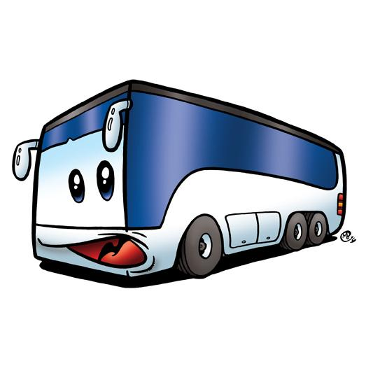 | Local Train  Pros: Good mode of transportation to the Kansai and Nagoya area  Cons: Can be long and costly if taken to any other region  Seishun 18 Ticket-青春18きっぷ  A JR train pass which allows 5 days of unlimited travel around the country on all local and rapid JR trains for only ¥11,850!  - It can be bought at most JR stations across Japan.  - It is only sold and available for use during the 3 school holiday periods throughout the year:  ♦Spring vacation: Mar 1 – Apr 10  ♦Summer vacation: July 20 – Sept 10  ♦Winter vacation: Dec 10 – Jan 10  - You can even share it between friends travelling together  - 5 people using 1 day each  - 2 people using 2 days each  For other times, a good way to go to the Kansai area is from Gifu or Ogaki Station. 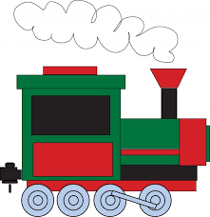 | Shinkansen  Pros:Fast  Cons: Can be expensive; often for non-reserved, you don’t get a seat  Platt Kodama / ぷらっとこだま- The Cheaper Shinkansen  - Book tickets in advance for the slower Kodama shinkansen and save a few thousand yen on your trips.  - Book your ticket at least 1 day in advance  - Book online, over the phone (in Japanese) or at the Tokai Tour Centre in JR Nagoya station  - Choose your departure time (every half hour)  - Get a free drink voucher!  For example:  With the regular shinkansen(One Way)  Nagoya<->Osaka=¥5840 non;reserved; ¥6500 reserved  Nagoya<->Tokyo=¥10,360 non-reserved; ¥11,000 reserved  With Platt Kodama(One Way)  Nagoya<->Osaka=¥4,400 reserved  Nagoya<->Tokyo=¥8,300 reserved  